**CSS Modules:**

CSS modules are not traditional CSS files, its class name and animation names are scoped locally by default. These are later processed by build tools such as webpack or browserify,

Next.JS has built in support for CSS modules.

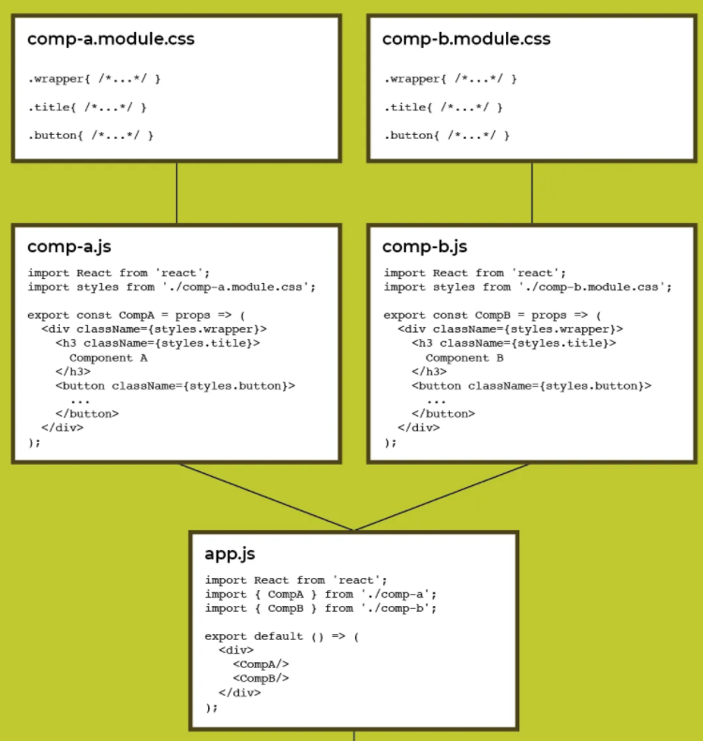

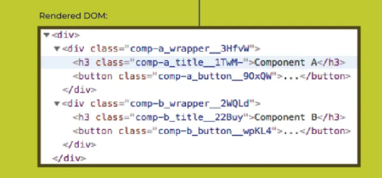

**Class Composition in CSS Modules:**

We can extend one or multiple classes at a time. This let us inherit styles from other classes, This is a great solution for naming conflict in large projects.

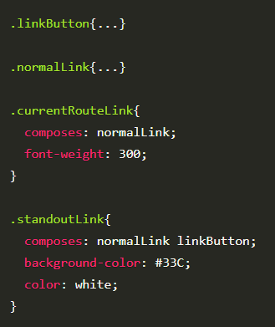

It is also possible to inherit from other modules.

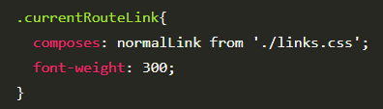

We can use multiple classes in an element using template literal.

